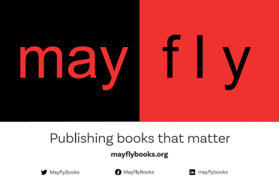

MayFly Books: Proposal Form

Thank you for approaching MayFly Books with your proposal.

MayFly Books is a truly not-for-profit publisher, interested in engagements with contemporary theorising concerned with critical organisation studies, critical and radical social sciences, social movements, environmental philosophy and their theoretical and political consequences and presumptions.

Here are some guidelines crafted to assist you in compiling the necessary details for us to review your proposal for potential publication.

About You

- Your Details

For each author or editor: title, name and affiliation along with your contact details.

- Brief Profile

For each author or editor: the list of works that are relevant to the proposed project. If any part of the content has already been published before, please provide complete details of it.

- Motivation

What is your motivation to publish with MayFly Books?

About Your Book

- Book Title, Subtitle (if any) and Key Words

- Rationale

Please distinguish what makes your book relevant in relation to existing literature in the subject area.

- Synopsis

Purpose, approach, scope, main themes and arguments, and methodology (no more than 400 words).

- Outline

Please provide information in the table below and feel free to add additional columns if required.

Chapter No | Chapter Title | Chapter Summary /  Main Arguments (no more than 200 words)

- Timeline

Is the manuscript ready?
If no, please provide a proposed timetable, including anticipated completion date, work already completed, other critical dates.

- Additional Information

If this book is fully or largely the outcome of a funded project, please provide details:

Please give an indication of the expected word length of the manuscript and number of images:

About Promotion

Please let us know the details of the promotion you might offer for the book (e.g. social media presence, public lectures, forthcoming academic conferences, network of contacts, book reviews)

Please date your proposal here: ……….. and mail to: mayflybooks1@gmail.com

Reviewing Your Proposal
Your proposed project will be evaluated first by the editors of
MayFly Collective. They will consider how the project fits with the ethos of MayFly Books. In case the collective agrees to take on the project, we will designate one or two editors who will get in touch with you to take the project forward. In case the collective rejects the proposed project, we will offer our comments.

